

Cyngor Tref Rhydaman
Ammanford Town Council

TO: ALL MEMBERS OF THE PERSONNEL COMMITTEE MEETING OF
AMMANFORD TOWN COUNCIL
DATE: 9TH JULY 2025

Dear Councillor,
In accordance with the Local Government and Elections (Wales) Act 2021 you are hereby summoned to attend a PERSONNEL COMMITTEE MEETING of AMMANFORD TOWN COUNCIL to be held on MS TEAMS ONLY, ON MONDAY 14TH JULY IMMEDIATELY FOLLOWING THE ASSET COMMITTEE MEETING.

AGENDA

- Apologies for absence
- Declarations of Interest
- To appoint a Chair of the Personnel Committee for 2025-26
- Public Participation
- To agree the Job Description for an Administration Assistant
- To discuss correspondence received from the Interim Clerk
Yours faithfully
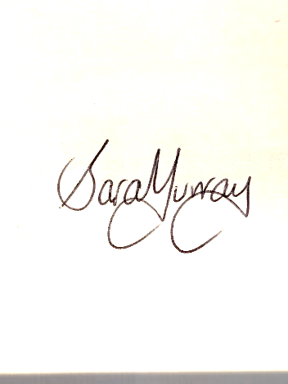
Sara Murray
Interim Clerk

MEMBERS OF THE PUBLIC AND PRESS MAY ATTEND ONLINE
It should be noted that owing to the sensitive nature of the business to be discussed under the ‘Exclusion of the public and the media under the Public Bodies (Admission to Meetings) Act 1960 Section 1 (2)’ a vote
may be undertaken by the Members/Councillors to pass a motion to exclude Members of the Public and Press from the meeting at any time after point 5.

Members of the Public and Press will then be asked to leave the meeting as the nature of the business to be discussed is of a sensitive nature in accordance with Local Government Act 1972, Section 100 A (2).

GALL AELODAU'R CYHOEDD A'R WASG FYNYCHU'N BERSONOL NEU AR-LEIN
Gofynnwn i aelodau o'r cyhoedd sy'n dymuno mynychu ddefnyddio'r ddolen isod. Rydym yn argymell eich bod yn gwirio eich cysylltiad 24 awr cyn y cyfarfod ac os ydych chi'n cael unrhyw broblemau, anfonwch e-bost at: Clerk@ammanford-tc.gov.uk

We request members of the public wishing to attend to please use the link below. We recommend you check your connection 24 hours in advance of the meeting and should you experience any issues please email: Clerk@ammanford-tc.gov.uk

Microsoft Teams Need help?
Join the meeting now
Meeting ID: 352 543 339 255 7
Passcode: 3go7dv9c

