
Cyngor Tref Rhydaman
Ammanford Town Council

TO: ALL MEMBERS OF THE FULL COUNCIL MEETING OF
AMMANFORD TOWN COUNCIL
DATE: 9th July 2025

Dear Councillor,
In accordance with the Local Government and Elections (Wales) Act 2021 you are hereby summoned to attend a FINANCE COMMITTE MEETING of AMMANFORD TOWN COUNCIL to be held VIA MS TEAMS, ON MONDAY 14th July at 6.00pm.

AGENDA

- Welcome, Apologies and reasons for absence.
- Declarations of interest.
- Matters arising from the public
- To receive a Finance update for June 2025
- To ratify payments made in June 2025
- To receive a written Finance Report for Qtr1 2025
- Virements to be approved for Budget 2025-2026

Yours faithfully
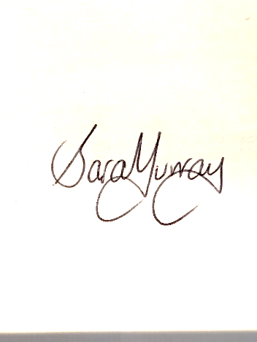
Sara Murray
Interim Clerk

MEMBERS OF THE PUBLIC AND PRESS MAY ATTEND ONLINE
We request members of the public wishing to attend to please use the link below. We recommend you check your connection 24 hours in advance of the meeting and should you experience any issues please email: Clerk@ammanford-tc.gov.uk
GALL AELODAU'R CYHOEDD A'R WASG FYNYCHU'N BERSONOL NEU AR-LEIN Gofynnwn i aelodau o'r cyhoedd sy'n dymuno mynychu ddefnyddio'r ddolen isod. Rydym yn argymell eich bod yn gwirio eich cysylltiad 24 awr cyn y cyfarfod ac os ydych chi'n cael unrhyw broblemau, anfonwch e-bost at: Clerk@ammanford-tc.gov.uk

Microsoft Teams Need help?
Join the meeting now
Meeting ID: 352 543 339 255 7
Passcode: 3go7dv9c

