
Cyngor Tref Rhydaman
Ammanford Town Council

TO: ALL MEMBERS OF AMMANFORD TOWN COUNCIL
DATE: 25th JUNE 2025

Dear Councillor,
You are hereby summoned to attend an EMERGENCY EXTRAORDINARY MEETING of AMMANFORD TOWN COUNCIL to be held at AMMANFORD TOWN HALL & VIA MS TEAMS, ON THURSDAY 26TH JUNE 2025 AT 6.00pm

AGENDA

1. Apologies and reasons for absence.
2. Declarations of interest.
3. To agree the Council’s Annual Return for the financial year ending 31st March 2025.
4. To agree one councillor, other than the Mayor, to sign the underlease required for Ammanford
Rugby Football Club relating to part of Ammanford Recreation ground.
5. To receive information regarding future operations and storage.

Yours faithfully
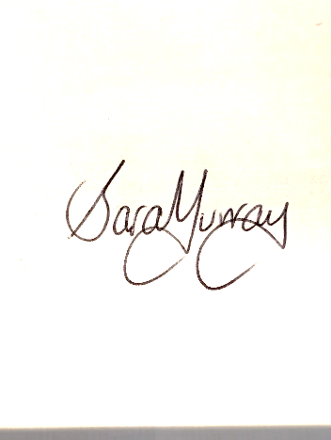
Sara Murray
Interim Clerk

MEMBERS OF THE PUBLIC AND PRESS MAY ATTEND IN PERSON OR ONLINE
It should be noted that owing to the sensitive nature of the business to be discussed under the ‘Exclusion of the public and the media under the Public Bodies (Admission to Meetings) Act 1960 Section 1 (2)’ a vote
may be undertaken by the Members/Councillors to pass a motion to exclude Members of the Public and Press from the meeting at any time after point 4.

Members of the Public and Press will then be asked to leave the meeting as the nature of the business to be discussed is of a sensitive nature in accordance with Local Government Act 1972, Section 100 A (2).

We request members of the public wishing to attend to please use the link below. We recommend you check your connection 24 hours in advance of the meeting and should you experience any issues please email: Clerk@ammanford-tc.gov.uk
Microsoft Teams Need help?
Join the meeting now
Meeting ID: 326 015 774 002 Passcode: Pr9R2XA3

