

Cyngor Tref Rhydaman
Ammanford Town Council

TO: ALL MEMBERS OF AMMANFORD TOWN COUNCIL
DATE: 21st May 2025

Dear Councillor,
In accordance with Local Government and Elections (Wales) Act 2021 you are hereby summoned to attend an EXTRA ORDINARY COUNCIL MEETING of AMMANFORD TOWN COUNCIL to be held at AMMANFORD TOWN HALL AND VIA MS TEAMS, ON TUESDAY 27TH MAY AT 6.00pm

AGENDA

1. Apologies and reasons for absence.

2. Declarations of interest.

3. To receive an update on Ammanford Town Hall

Yours Faithfully

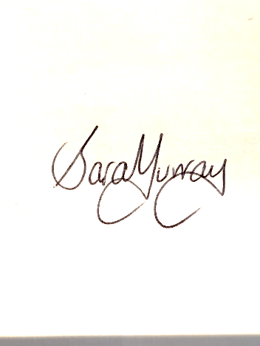

Mrs Sara Murray
Interim Clerk

In accordance with the Public Bodies (Admission to Meetings) Act 1960, s1(2) and the Local
Government Act 1972, s,100(2), members of the public and press are not able to attend the meeting
due to the nature of the information to be discussed.

